**Peer Review on Bluetooth and Wifi Analyzer**

**Bluetooth Scan using Bluescan and BLE Scanner:**

**BLE Scanner:**

The photos show the analysis part from BLE Scanner app of the available devices near us and the photos are below here:

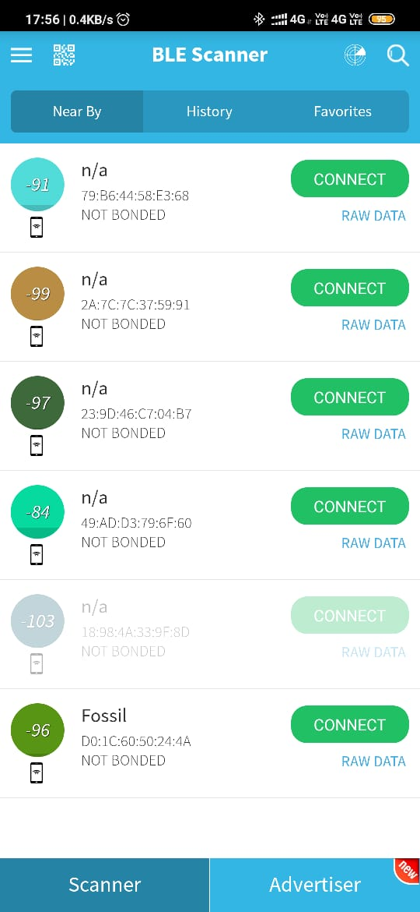

Negative Value represent the RSSID Value between Device and Bluetooth Device.

**Photo obtained through Scanning:**

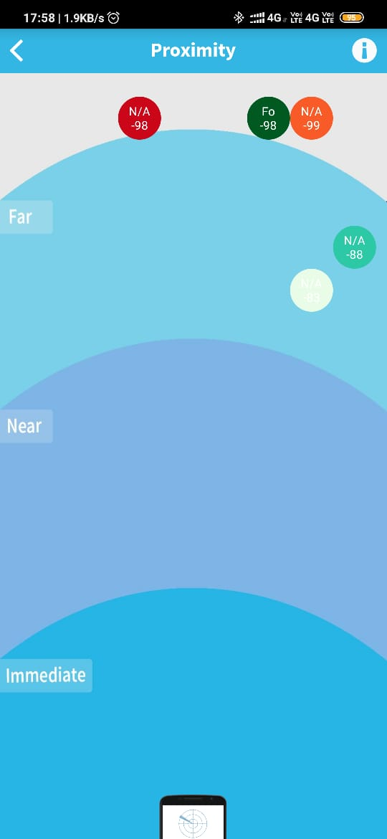

Negative Value represent the RSSID Value between Device and Bluetooth Device.

**Photo of Raw Data of Connection:**

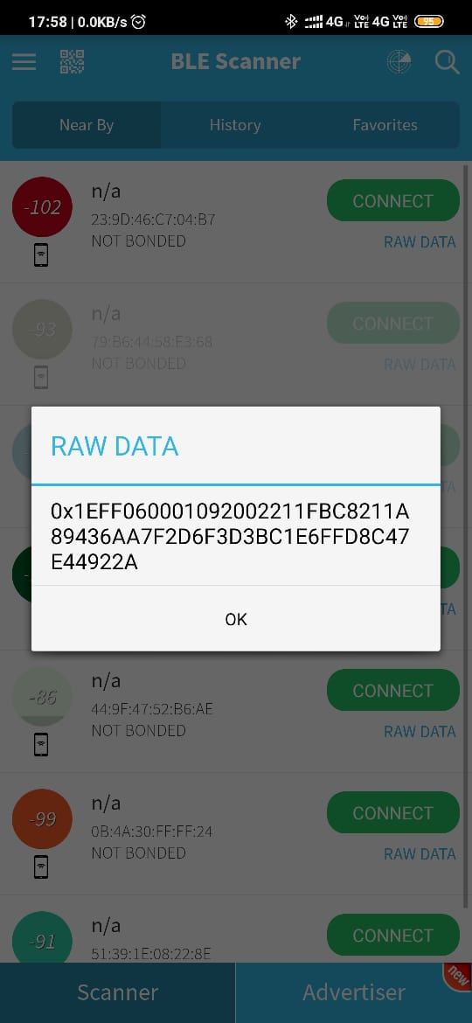

**Other Photos of Application Working:**

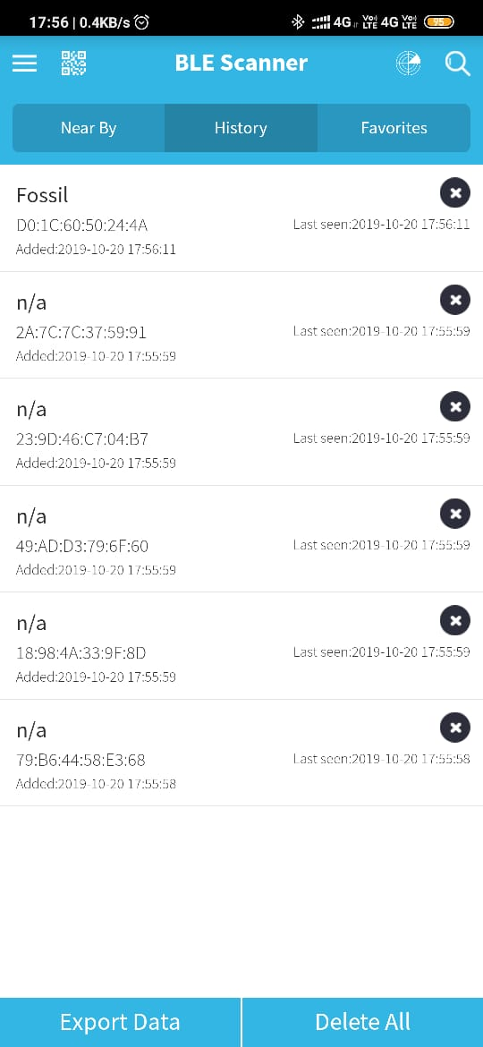

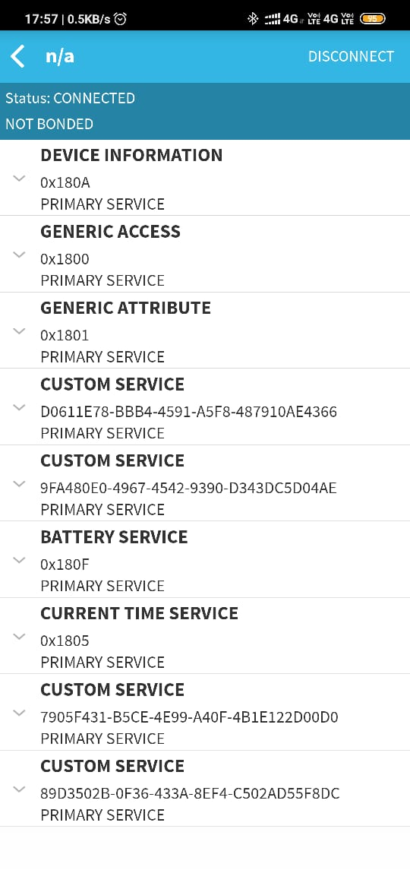

**Bluescan Application:**

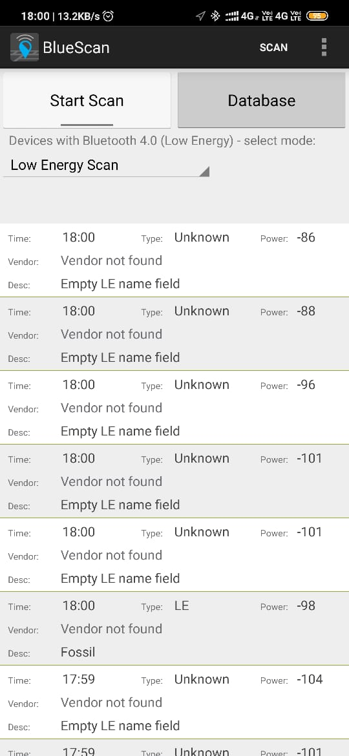

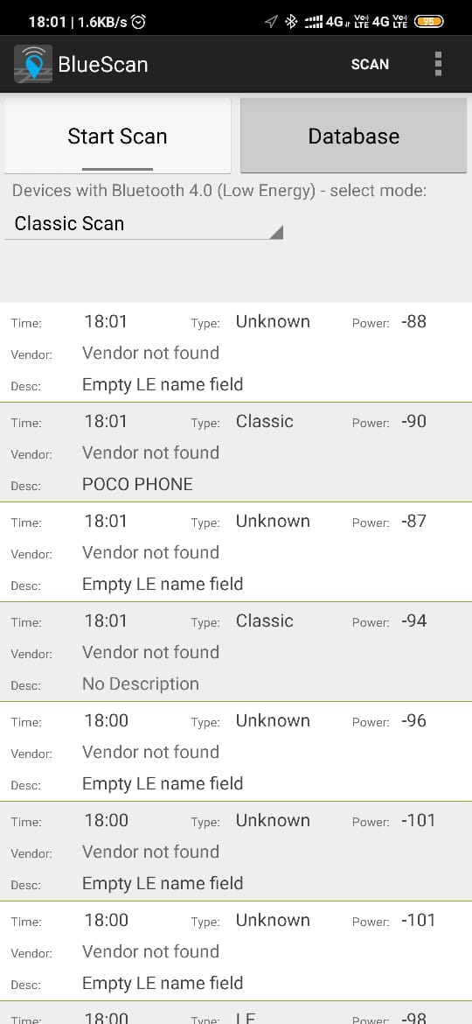

**Photos Obtained from Wi-Fi Analyzer:**

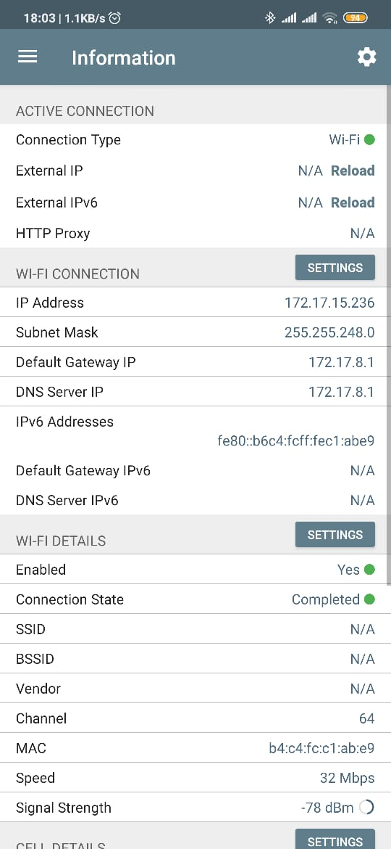

**When WiFi is Connected**

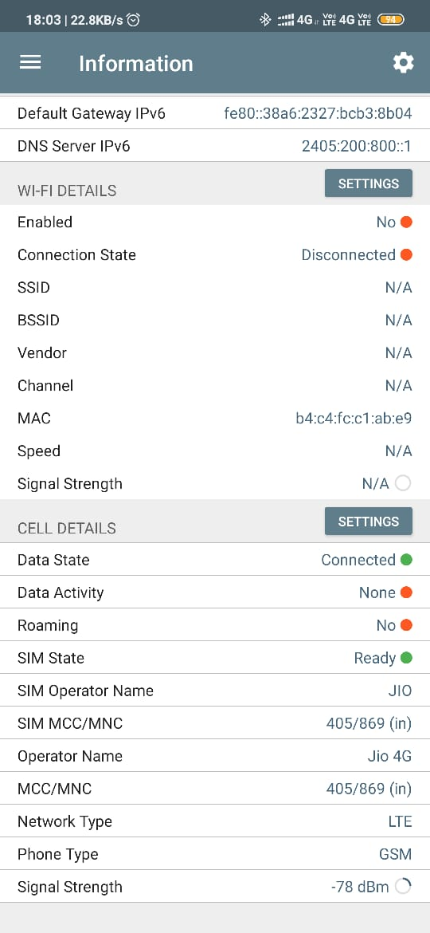

**When Mobile Data is Connected**

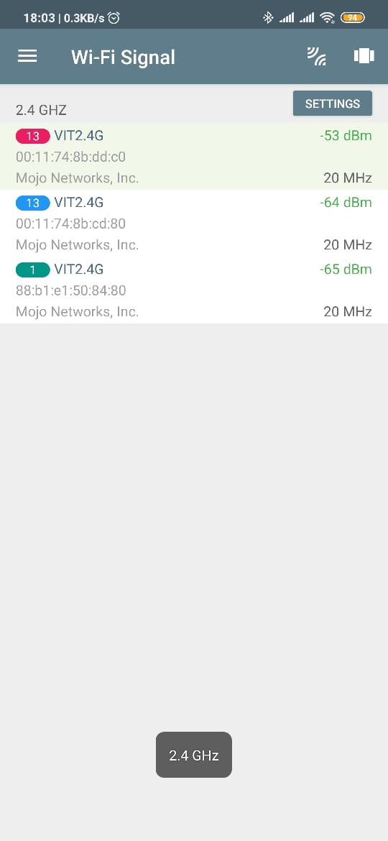

**Connections under 2.4GHz Frequency**

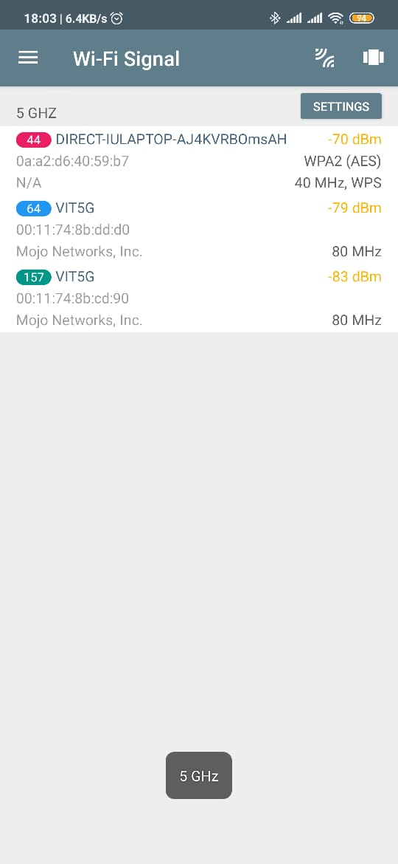

**Connections under 5GHz Frequency**

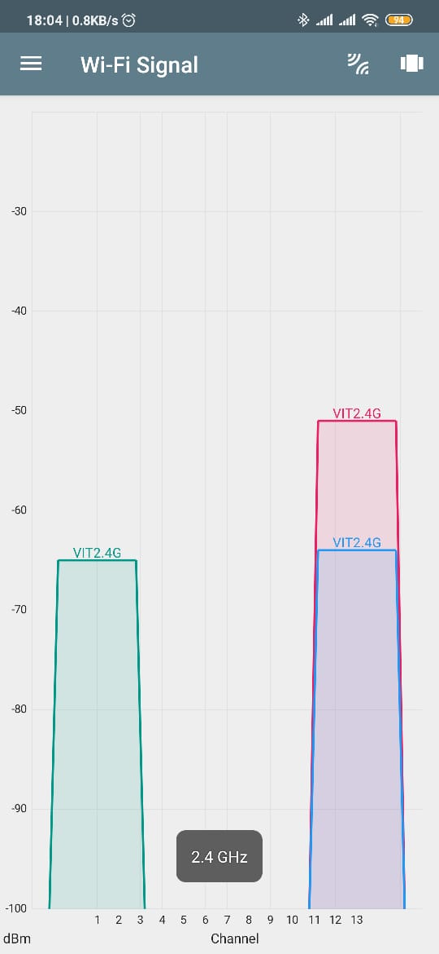

**Graph for Connections under 2.4GHz Frequency**

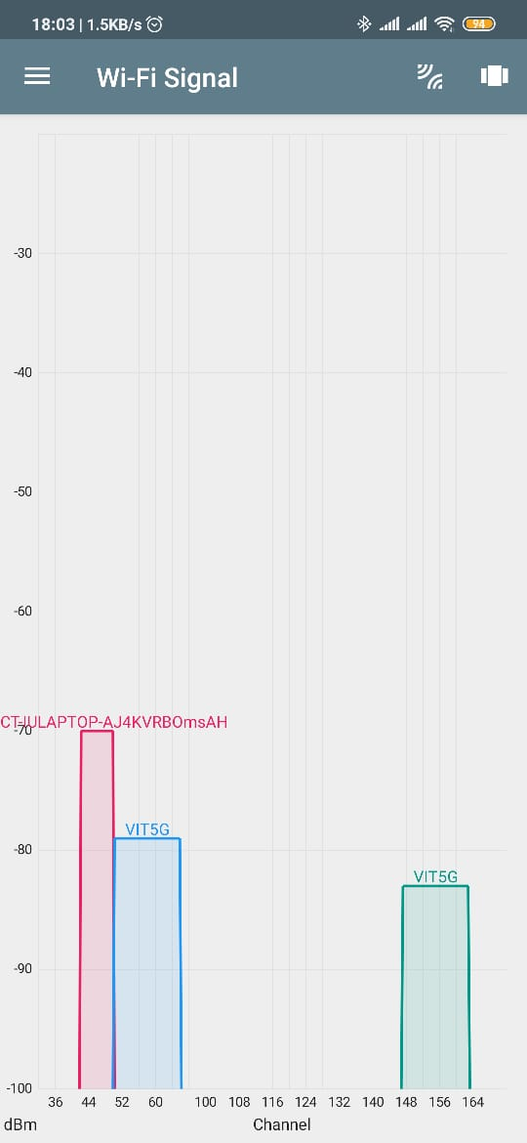

**Graph for Connections under 5GHz Frequency**

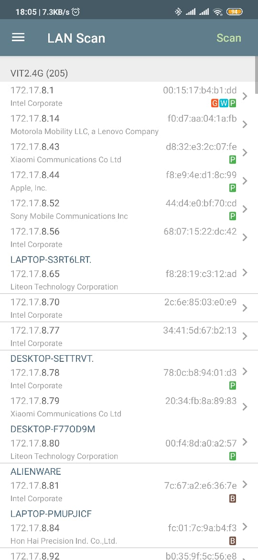

**Connections Obtained through LAN Scan**

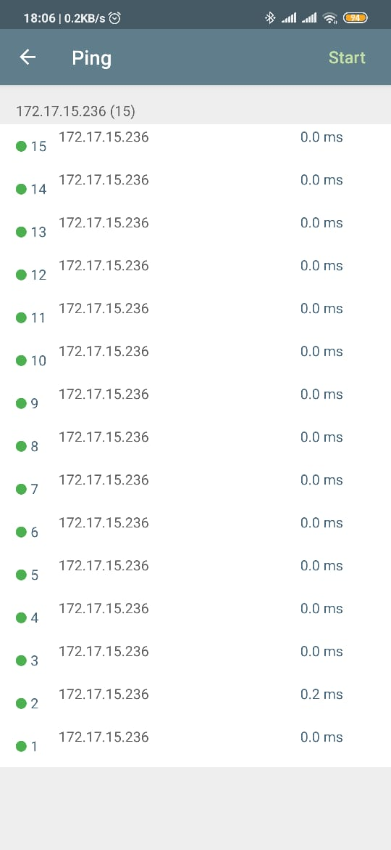

**Ping of the Connection**

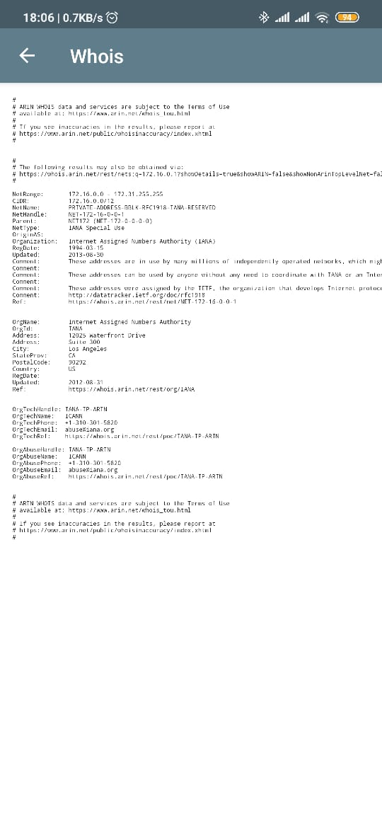

**Whois of the Connection**